|  |
| --- |
| **VISVESVARAYA TECHNOLOGICAL UNIVERSITY**  **“JnanaSangama”, Belgaum -590014, Karnataka.**    **LAB RECORD**  **Bio Inspired Systems (23CS5BSBIS)**  ***Submitted by***  **K L SRUJAN (1BM24CS408)**  ***in partial fulfillment for the award of the degree of***  **BACHELOR OF ENGINEERING**  ***in***  **COMPUTER SCIENCE AND ENGINEERING**    **B.M.S. COLLEGE OF ENGINEERING**  **(Autonomous Institution under VTU)**  **BENGALURU-560019**  **Aug-2025 to Dec-2025** |

**B.M.S. College of Engineering,**

**Bull Temple Road, Bangalore 560019**

(Affiliated To Visvesvaraya Technological University, Belgaum)

**Department of Computer Science and Engineering**



**CERTIFICATE**

This is to certify that the Lab work entitled “ Bio Inspired Systems (23CS5BSBIS)” carried out by **K L SRUJAN (1BM24CS408),** who is bonafide student of **B.M.S. College of Engineering.** It is in partial fulfillment for the award of **Bachelor of Engineering in Computer Science and Engineering** of the Visvesvaraya Technological University, Belgaum. The Lab report has been approved as it satisfies the academic requirements of the above mentioned subject and the work prescribed for the said degree.

|  |  |
| --- | --- |
| **Sowmya T**  Assistant Professor  Department of CSE, BMSCE | Dr. Kavitha Sooda  Professor & HOD  Department of CSE, BMSCE |

**Index**

|  |  |  |  |
| --- | --- | --- | --- |
| **Sl.**  **No.** | **Date** | **Experiment Title** | **Page No.** |
| 1 | 18/8/25 | **Genetic Algorithm for Optimization Problems** | 4-11 |
| 2 | 25/8/25 | Particle Swarm Optimization for Function Optimization | 12-16 |
| 3 | 1/9/25 | Ant Colony Optimization for the Traveling Salesman Problem | 17-21 |
| 4 | 8/9/25 | Cuckoo Search (CS) | 22-26 |
| 5 | 15/9/25 | Grey Wolf Optimizer (GWO) | 27-33 |
| 6 | 6/10/25 | Parallel Cellular Algorithms and Programs | 34-37 |
| 7 | 13/10/25 | Optimization via Gene Expression Algorithms | 38-42 |

Github Link: <https://github.com/K-L-SRUJAN/BIS>

**Program 1: Genetic Algorithm for Optimization Problems**

Find an optimal or near-optimal solution to a nonlinear optimization problem where the search space is large and complex, such as minimizing a multi-variable cost function with multiple local minima.

**Algorithm**:

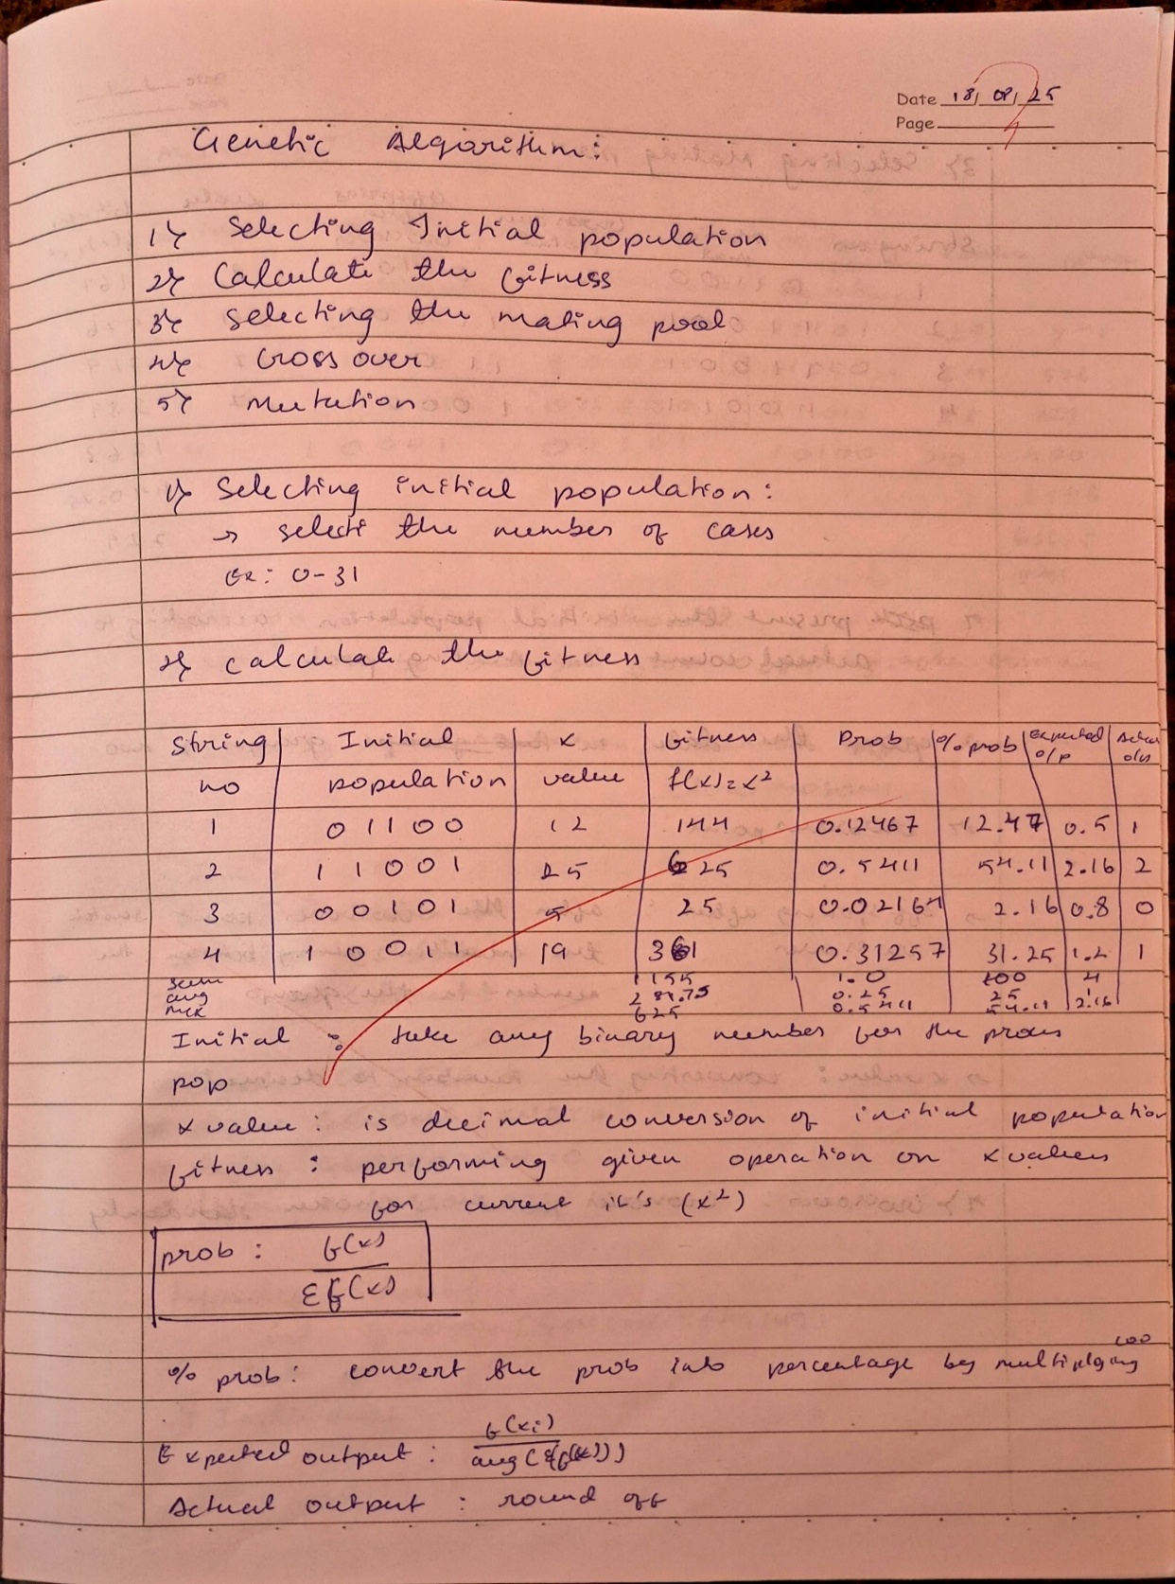

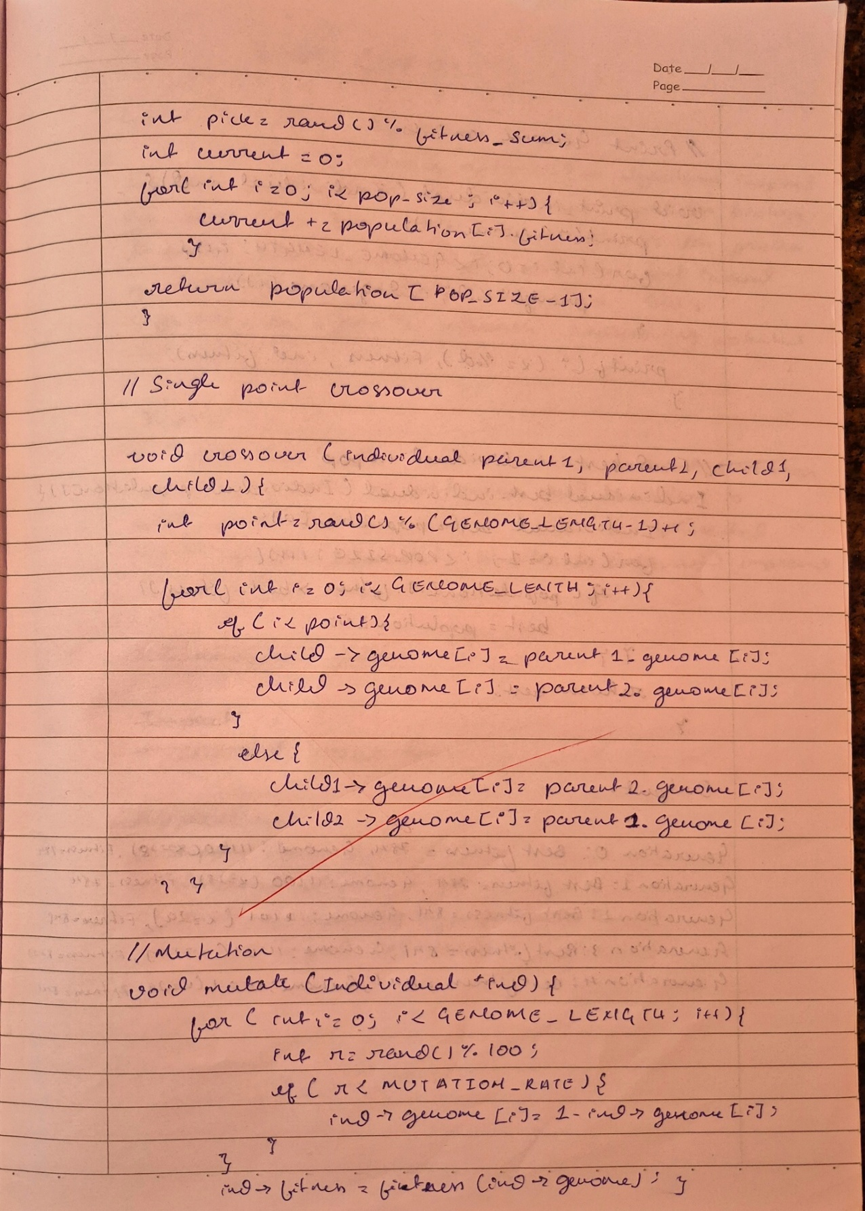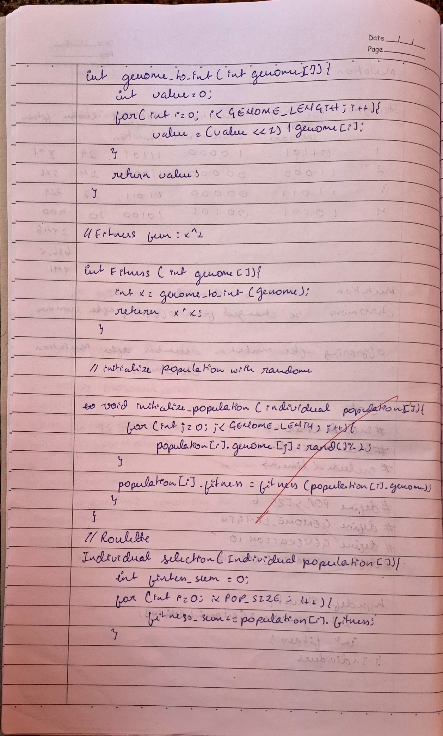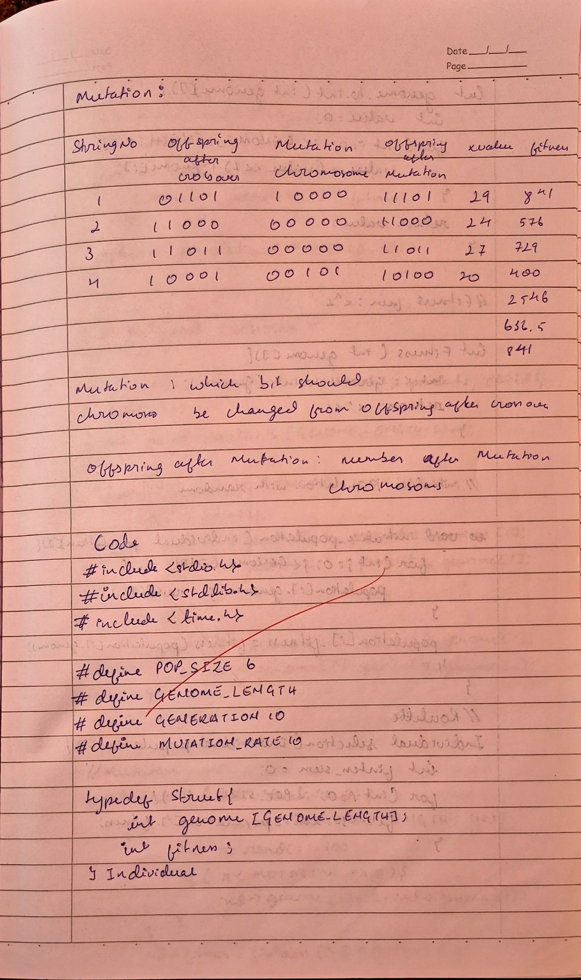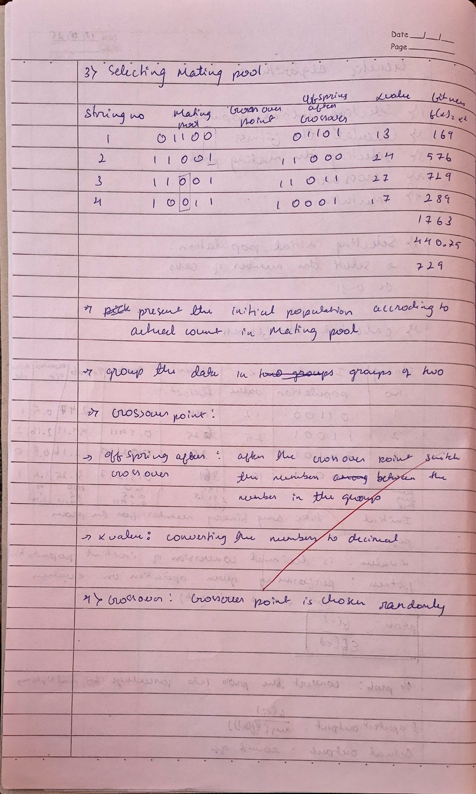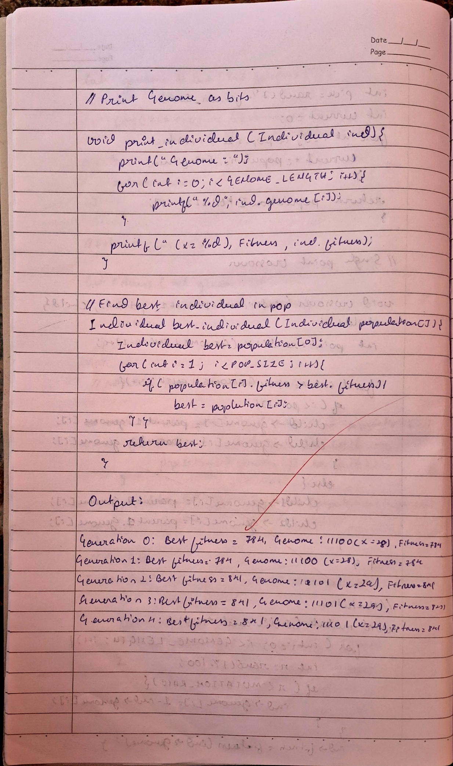

**Code:**

import random

# Constants

POP_SIZE = 6

GENOME_LENGTH = 5 # 5 bits for values 0-31

GENERATIONS = 5

MUTATION_RATE = 10 # Percentage

class Individual:

def __init__(self):

self.genome = [random.randint(0, 1) for _ in range(GENOME_LENGTH)]

self.fitness = self.calculate_fitness()

def calculate_fitness(self):

x = self.genome_to_int()

return x * x

def genome_to_int(self):

value = 0

for bit in self.genome:

value = (value << 1) | bit

return value

def mutate(self):

for i in range(GENOME_LENGTH):

if random.randint(0, 99) < MUTATION_RATE:

self.genome[i] ^= 1 # Flip the bit

self.fitness = self.calculate_fitness()

def __str__(self):

return f"Genome: {''.join(map(str, self.genome))} (x={self.genome_to_int()}), Fitness={self.fitness}"

def initialize_population():

return [Individual() for _ in range(POP_SIZE)]

def selection(population):

total_fitness = sum(ind.fitness for ind in population)

pick = random.randint(0, total_fitness - 1)

current = 0

for ind in population:

current += ind.fitness

if current > pick:

return ind

return population[-1]

def crossover(parent1, parent2):

point = random.randint(1, GENOME_LENGTH - 1)

child1 = Individual()

child2 = Individual()

child1.genome = parent1.genome[:point] + parent2.genome[point:]

child2.genome = parent2.genome[:point] + parent1.genome[point:]

child1.fitness = child1.calculate_fitness()

child2.fitness = child2.calculate_fitness()

return child1, child2

def best_individual(population):

return max(population, key=lambda ind: ind.fitness)

def main():

random.seed()

population = initialize_population()

for gen in range(GENERATIONS):

# Sort by fitness (descending)

population.sort(key=lambda ind: ind.fitness, reverse=True)

print(f"Generation {gen}: Best fitness = {population[0].fitness}, {population[0]}")

# Elitism: keep top 2

new_population = [population[0], population[1]]

while len(new_population) < POP_SIZE:

parent1 = selection(population)

parent2 = selection(population)

child1, child2 = crossover(parent1, parent2)

child1.mutate()

child2.mutate()

new_population.append(child1)

if len(new_population) < POP_SIZE:

new_population.append(child2)

population = new_population

best = best_individual(population)

print("\nBest solution found:")

print(best)

if __name__ == "__main__":

main()

**Program 2**: Particle Swarm Optimization for Function Optimization

Minimize a given continuous mathematical function by finding the variable values that produce the lowest output, using swarm-based search through the solution space.

**Algorithm:**

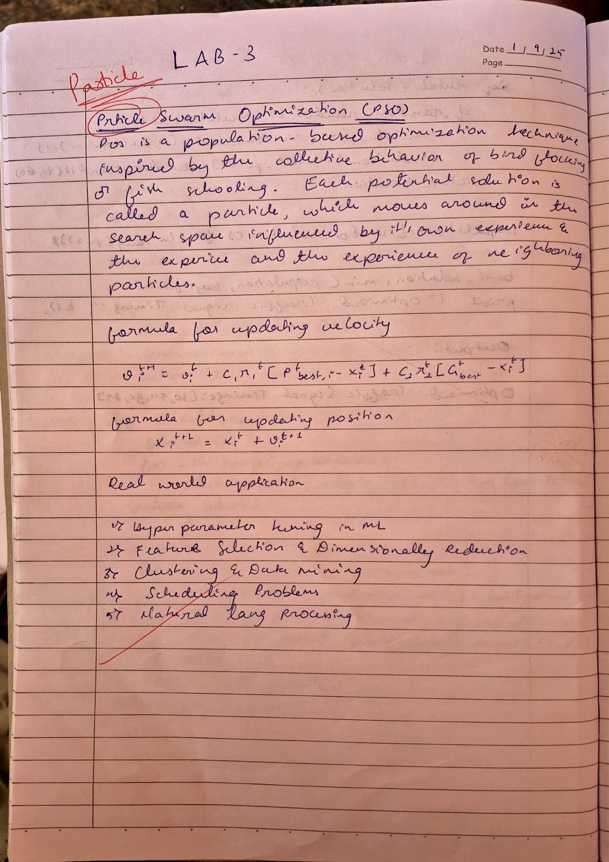

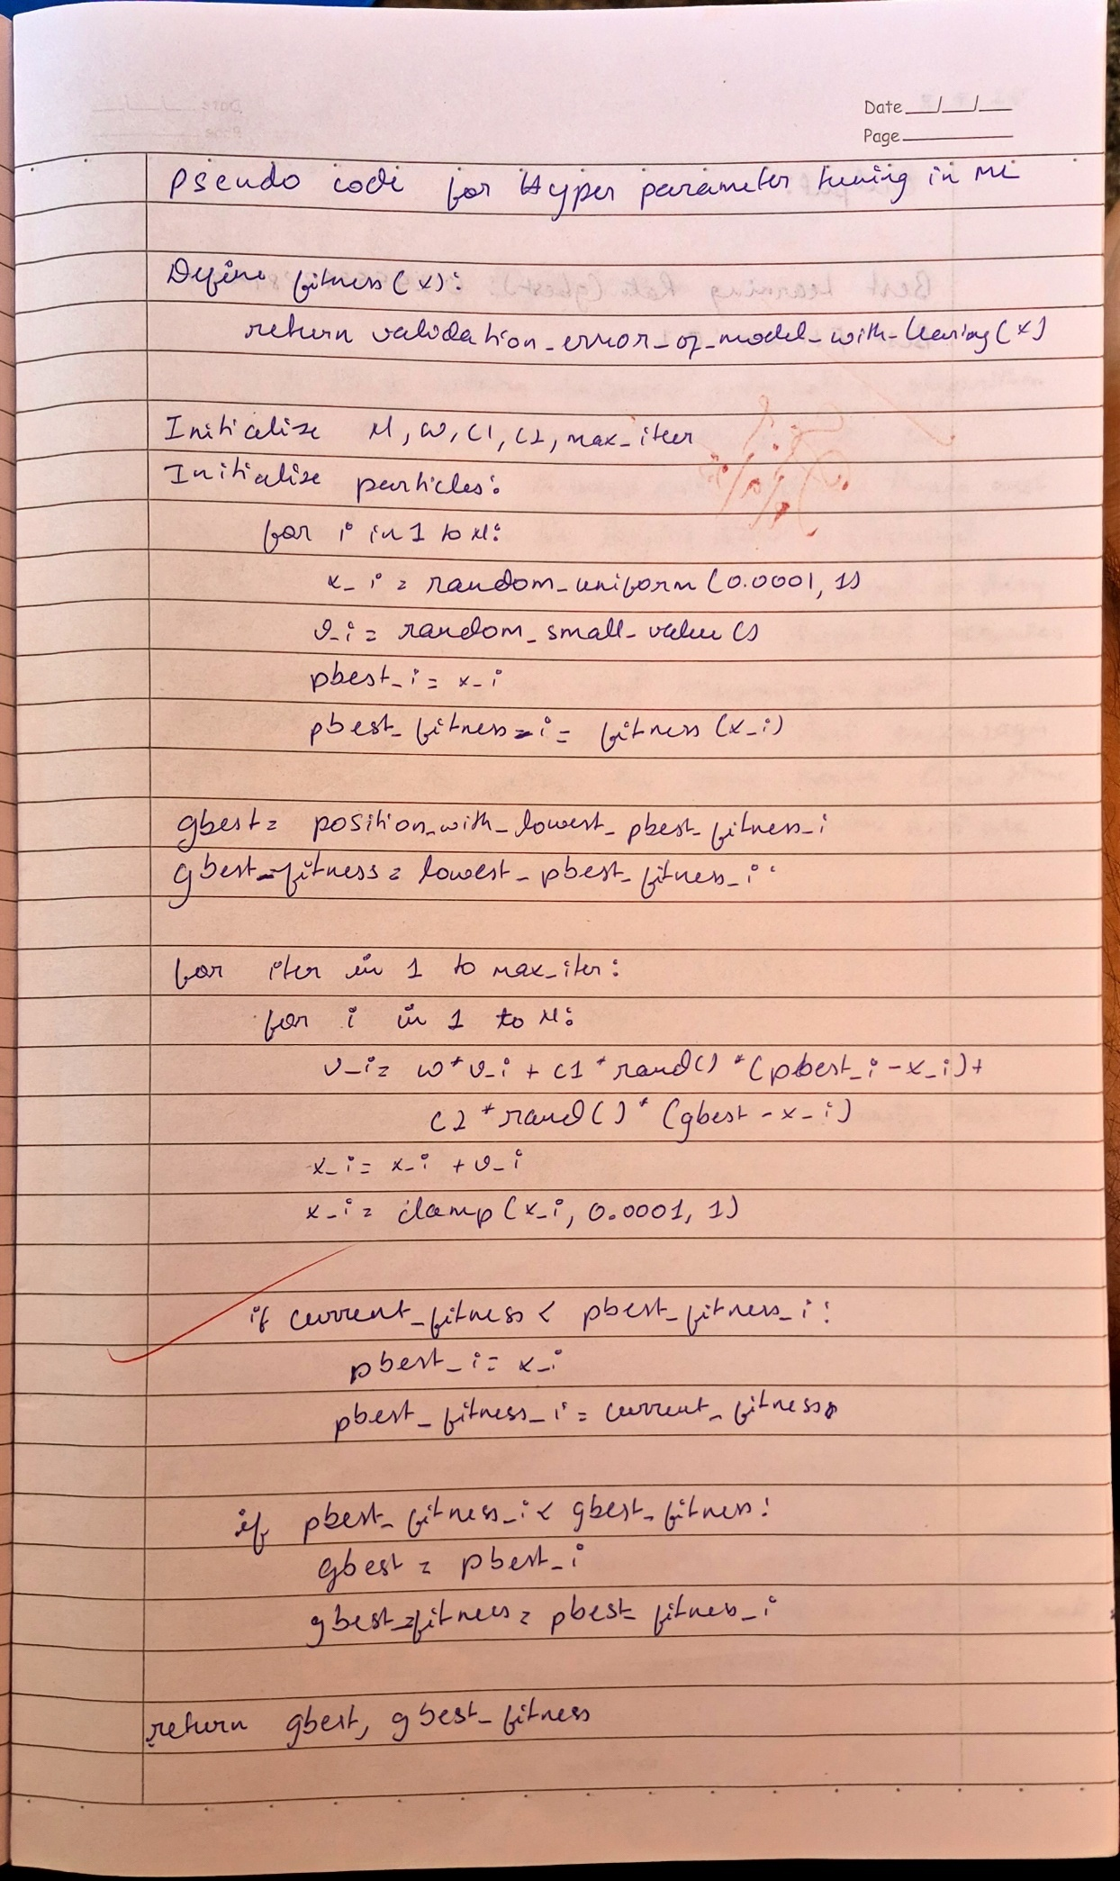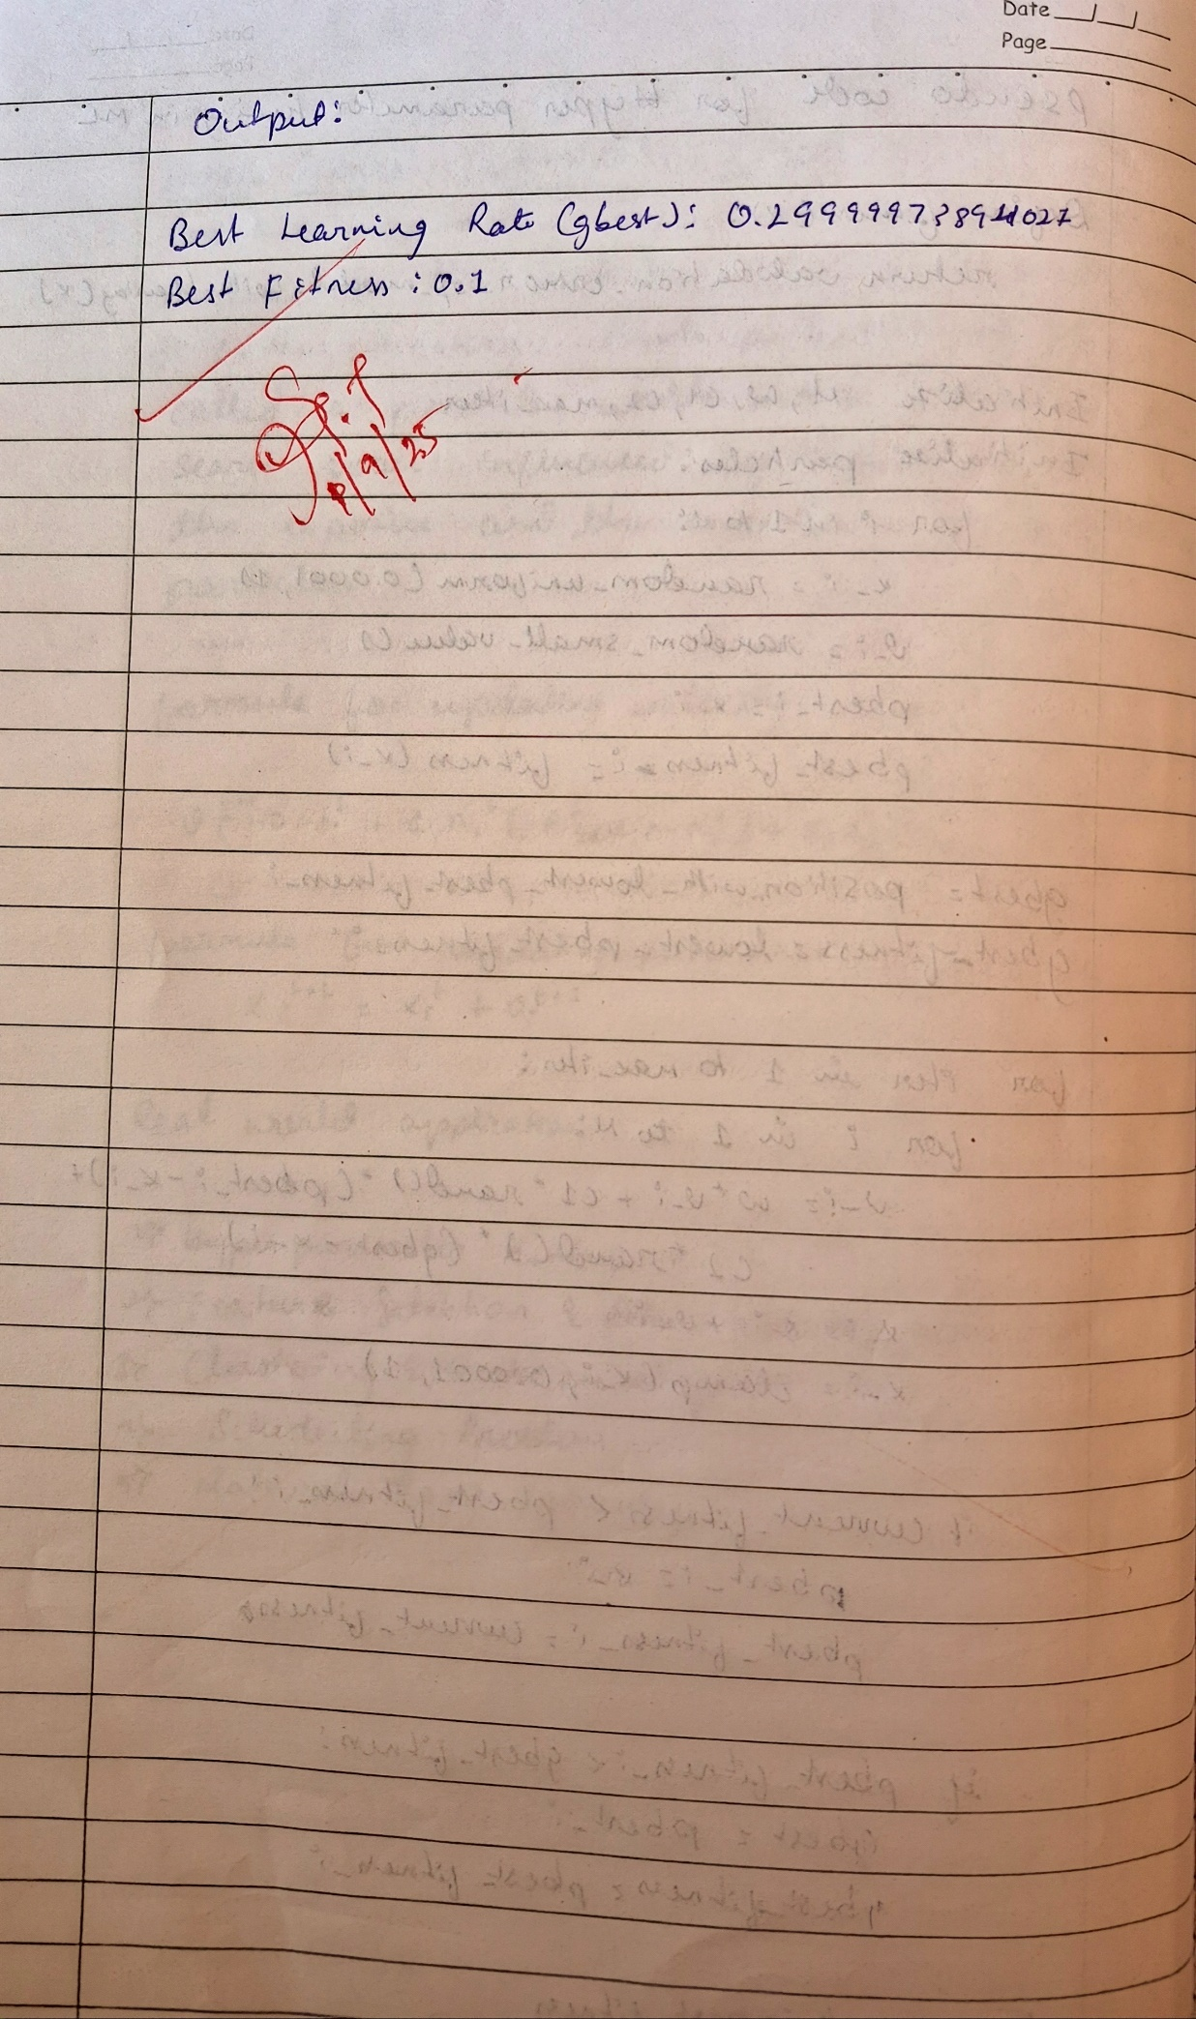

**Code:**

import random

import numpy as np

def fitness(x):

return (x - 0.3) ** 2 + 0.1

def pso(num_particles=10, w=0.5, c1=1.5, c2=1.5, max_iter=100):

particles = []

velocities = []

pbest = []

pbest_fitness = []

for _ in range(num_particles):

x_i = random.uniform(0.0001, 1)

v_i = random.uniform(-0.01, 0.01)

f_i = fitness(x_i)

particles.append(x_i)

velocities.append(v_i)

pbest.append(x_i)

pbest_fitness.append(f_i)

gbest_index = np.argmin(pbest_fitness)

gbest = pbest[gbest_index]

gbest_fitness = pbest_fitness[gbest_index]

for _ in range(max_iter):

for i in range(num_particles):

r1, r2 = random.random(), random.random()

velocities[i] = (

w * velocities[i]

+ c1 * r1 * (pbest[i] - particles[i])

+ c2 * r2 * (gbest - particles[i])

)

particles[i] += velocities[i]

particles[i] = max(0.0001, min(1, particles[i]))

f_i = fitness(particles[i])

if f_i < pbest_fitness[i]:

pbest[i] = particles[i]

pbest_fitness[i] = f_i

if f_i < gbest_fitness:

gbest = particles[i]

gbest_fitness = f_i

return gbest, gbest_fitness

best_x, best_fit = pso()

print("Best Learning Rate (gbest):", best_x)

print("Best Fitness:", best_fit)

**Program 3 :** Ant Colony Optimization for the Traveling Salesman Problem

Determine the shortest possible route that visits all cities exactly once and returns to the starting point, using probabilistic path selection inspired by pheromone trails.

**Algorithm:**

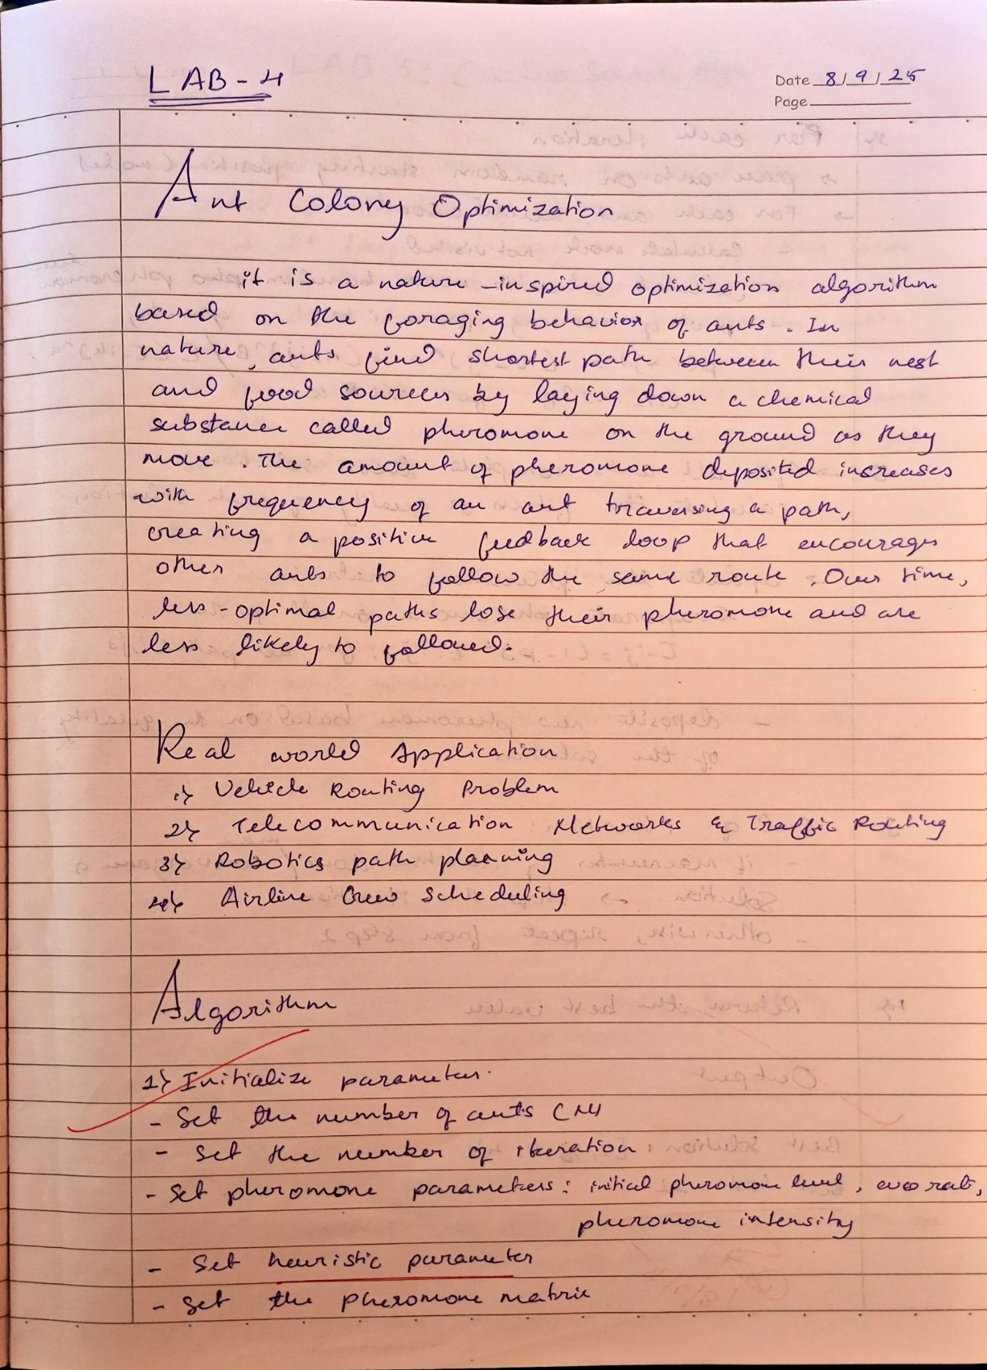 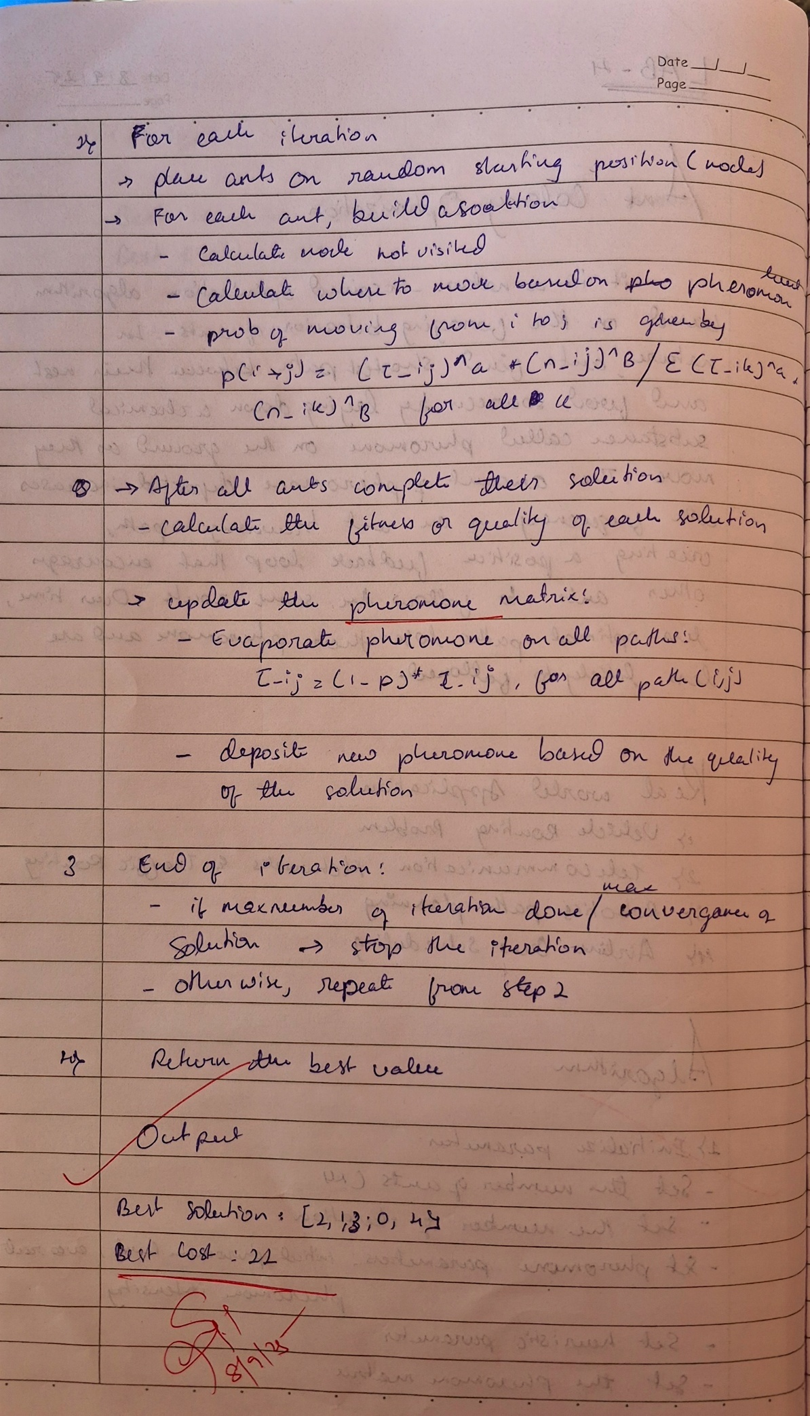

**Code:**

import random

import math

import numpy as np

def initialize_aco(num_ants, num_cities, pheromone_init, alpha, beta, rho, Q):

pheromone_matrix = np.full((num_cities, num_cities), pheromone_init)

best_solution = None

best_cost = float('inf')

return pheromone_matrix, best_solution, best_cost

def build_solution(pheromone_matrix, alpha, beta, num_cities, heuristic_matrix):

visited = [False] * num_cities

solution = []

current_city = random.randint(0, num_cities - 1)

visited[current_city] = True

solution.append(current_city)

for _ in range(num_cities - 1):

next_city = select_next_city(current_city, visited, pheromone_matrix, alpha, beta, heuristic_matrix, num_cities)

solution.append(next_city)

visited[next_city] = True

current_city = next_city

return solution

def select_next_city(current_city, visited, pheromone_matrix, alpha, beta, heuristic_matrix, num_cities):

probabilities = []

total_prob = 0.0

for next_city in range(num_cities):

if not visited[next_city]:

pheromone = pheromone_matrix[current_city][next_city]

heuristic = heuristic_matrix[current_city][next_city]

prob = (pheromone ** alpha) * (heuristic ** beta)

total_prob += prob

probabilities.append(prob)

else:

probabilities.append(0)

probabilities = [prob / total_prob for prob in probabilities]

return roulette_wheel_selection(probabilities)

def roulette_wheel_selection(probabilities):

rand = random.random()

cumulative_prob = 0.0

for i, prob in enumerate(probabilities):

cumulative_prob += prob

if cumulative_prob >= rand:

return i

return len(probabilities) - 1

def evaluate_solution(solution, distance_matrix):

total_distance = 0

for i in range(len(solution) - 1):

total_distance += distance_matrix[solution[i]][solution[i + 1]]

total_distance += distance_matrix[solution[-1]][solution[0]]

return total_distance

def update_pheromones(pheromone_matrix, solutions, distances, rho, Q):

pheromone_matrix *= (1 - rho)

for i, solution in enumerate(solutions):

for j in range(len(solution) - 1):

pheromone_matrix[solution[j]][solution[j + 1]] += Q / distances[i]

pheromone_matrix[solution[-1]][solution[0]] += Q / distances[i]

def ACO(num_ants, num_cities, distance_matrix, pheromone_init, alpha, beta, rho, Q, max_iterations):

pheromone_matrix, best_solution, best_cost = initialize_aco(num_ants, num_cities, pheromone_init, alpha, beta, rho, Q)

for iteration in range(max_iterations):

solutions = []

distances = []

for _ in range(num_ants):

solution = build_solution(pheromone_matrix, alpha, beta, num_cities, distance_matrix)

solutions.append(solution)

cost = evaluate_solution(solution, distance_matrix)

distances.append(cost)

if cost < best_cost:

best_cost = cost

best_solution = solution

update_pheromones(pheromone_matrix, solutions, distances, rho, Q)

print(f"Iteration {iteration + 1}, Best Cost: {best_cost}")

return best_solution, best_cost

num_cities = 5

num_ants = 10

max_iterations = 100

pheromone_init = 0.1

alpha = 1.0

beta = 2.0

rho = 0.5

Q = 100

distance_matrix = [

[0, 2, 9, 10, 1],

[1, 0, 6, 4, 3],

[15, 7, 0, 8, 6],

[6, 3, 12, 0, 5],

[10, 8, 4, 6, 0]

]

heuristic_matrix = np.array([[1 / distance_matrix[i][j] if distance_matrix[i][j] > 0 else 0 for j in range(num_cities)] for i in range(num_cities)])

best_solution, best_cost = ACO(num_ants, num_cities, distance_matrix, pheromone_init, alpha, beta, rho, Q, max_iterations)

print("Best Solution:", best_solution)

print("Best Cost:", best_cost)

**Program 4:** Cuckoo Search (CS)

Optimize a multimodal function by identifying the global minimum using Lévy-flight-based exploration combined with nest-selection strategies.

**Algorithm**

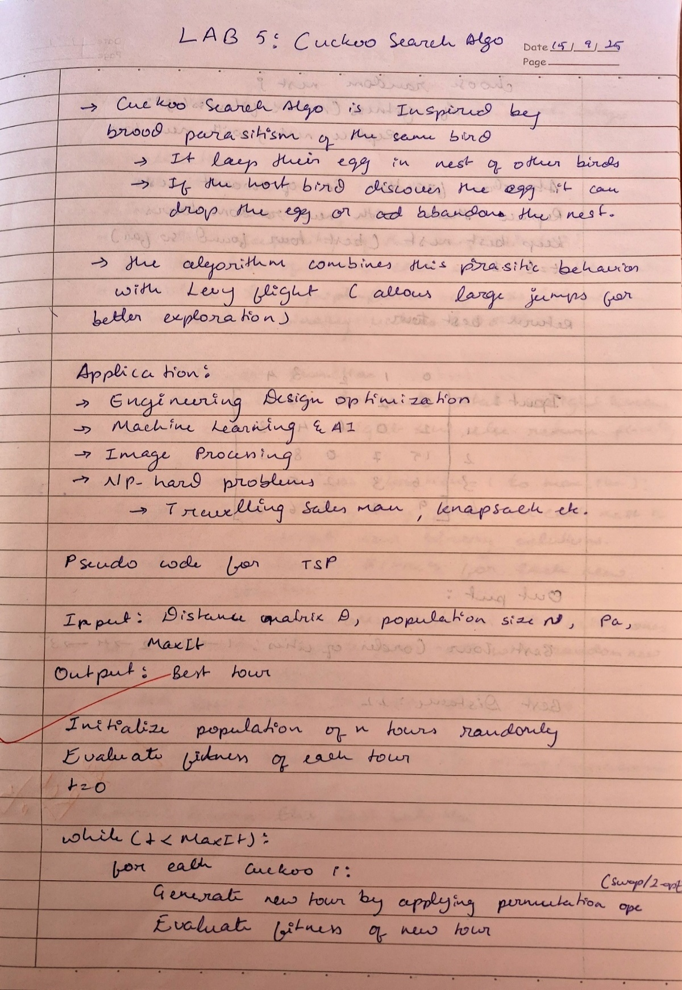

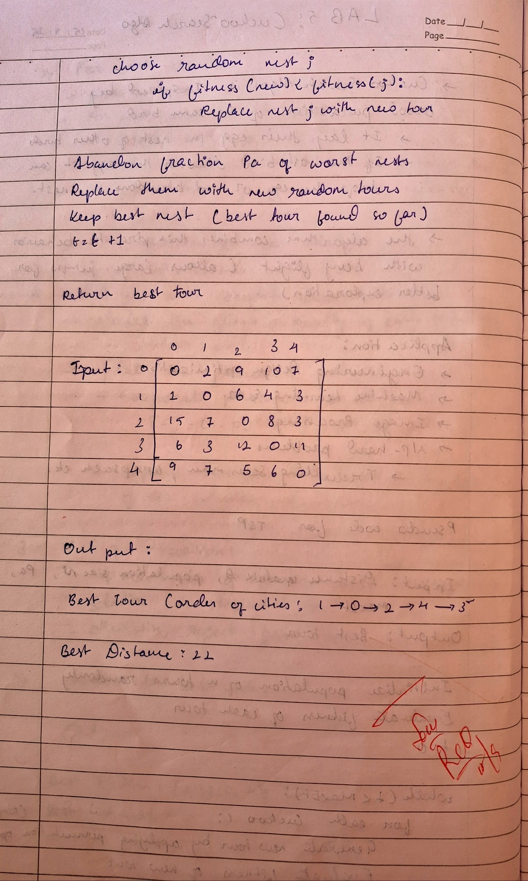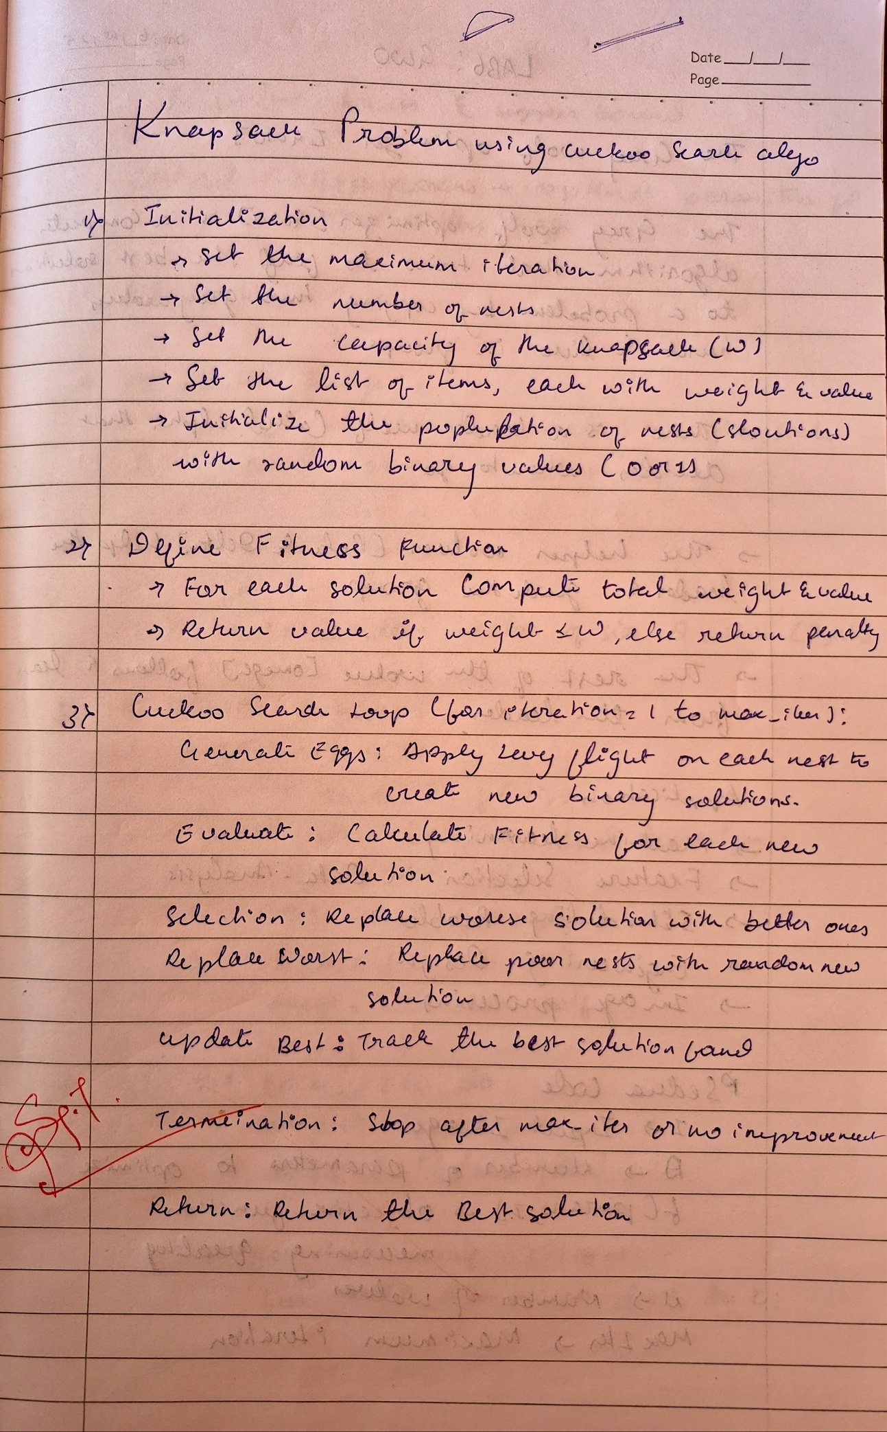

**Code:**

import numpy as np

import random

def total_distance(tour, dist_matrix):

d = 0

for i in range(len(tour)):

d += dist_matrix[tour[i - 1]][tour[i]]

return d

def levy_flight_solution(tour):

new_tour = tour.copy()

i, j = sorted(random.sample(range(len(tour)), 2))

new_tour[i:j] = reversed(new_tour[i:j])

return new_tour

def cuckoo_search_tsp(dist_matrix, n=20, Pa=0.25, MaxIt=500):

num_cities = len(dist_matrix)

nests = [random.sample(range(num_cities), num_cities) for _ in range(n)]

fitness = [total_distance(tour, dist_matrix) for tour in nests]

best_idx = np.argmin(fitness)

best_tour = nests[best_idx]

best_fitness = fitness[best_idx]

for t in range(MaxIt):

for i in range(n):

new_tour = levy_flight_solution(nests[i])

new_fit = total_distance(new_tour, dist_matrix)

j = random.randint(0, n-1)

if new_fit < fitness[j]:

nests[j] = new_tour

fitness[j] = new_fit

num_abandon = int(Pa * n)

worst_idx = np.argsort(fitness)[-num_abandon:]

for idx in worst_idx:

nests[idx] = random.sample(range(num_cities), num_cities)

fitness[idx] = total_distance(nests[idx], dist_matrix)

curr_best_idx = np.argmin(fitness)

if fitness[curr_best_idx] < best_fitness:

best_tour = nests[curr_best_idx]

best_fitness = fitness[curr_best_idx]

return best_tour, best_fitness

if __name__ == "__main__":

dist_matrix = [

[0, 2, 9, 10, 7],

[1, 0, 6, 4, 3],

[15, 7, 0, 8, 3],

[6, 3, 12, 0, 11],

[9, 7, 5, 6, 0]

]

best_tour, best_dist = cuckoo_search_tsp(dist_matrix, n=20, Pa=0.25, MaxIt=500)

print("Best Tour (order of cities):", best_tour)

print("Best Distance:", best_dist)

**Program 5:** Grey Wolf Optimizer (GWO)

Find the optimal solution to a continuous optimization problem by simulating the leadership hierarchy and hunting behavior of grey wolves.

Algorithm:

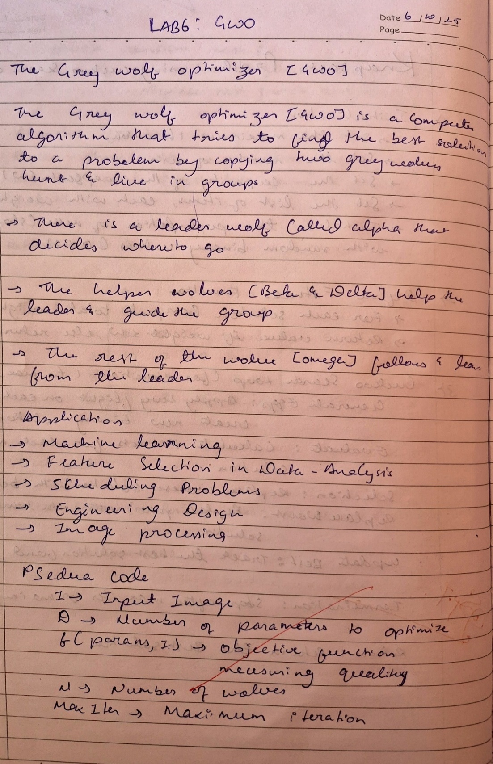

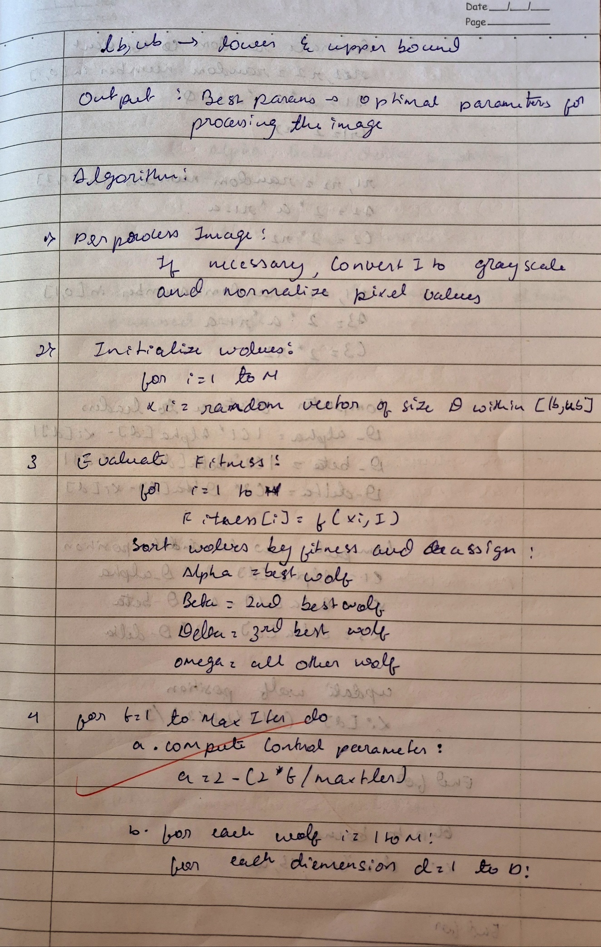

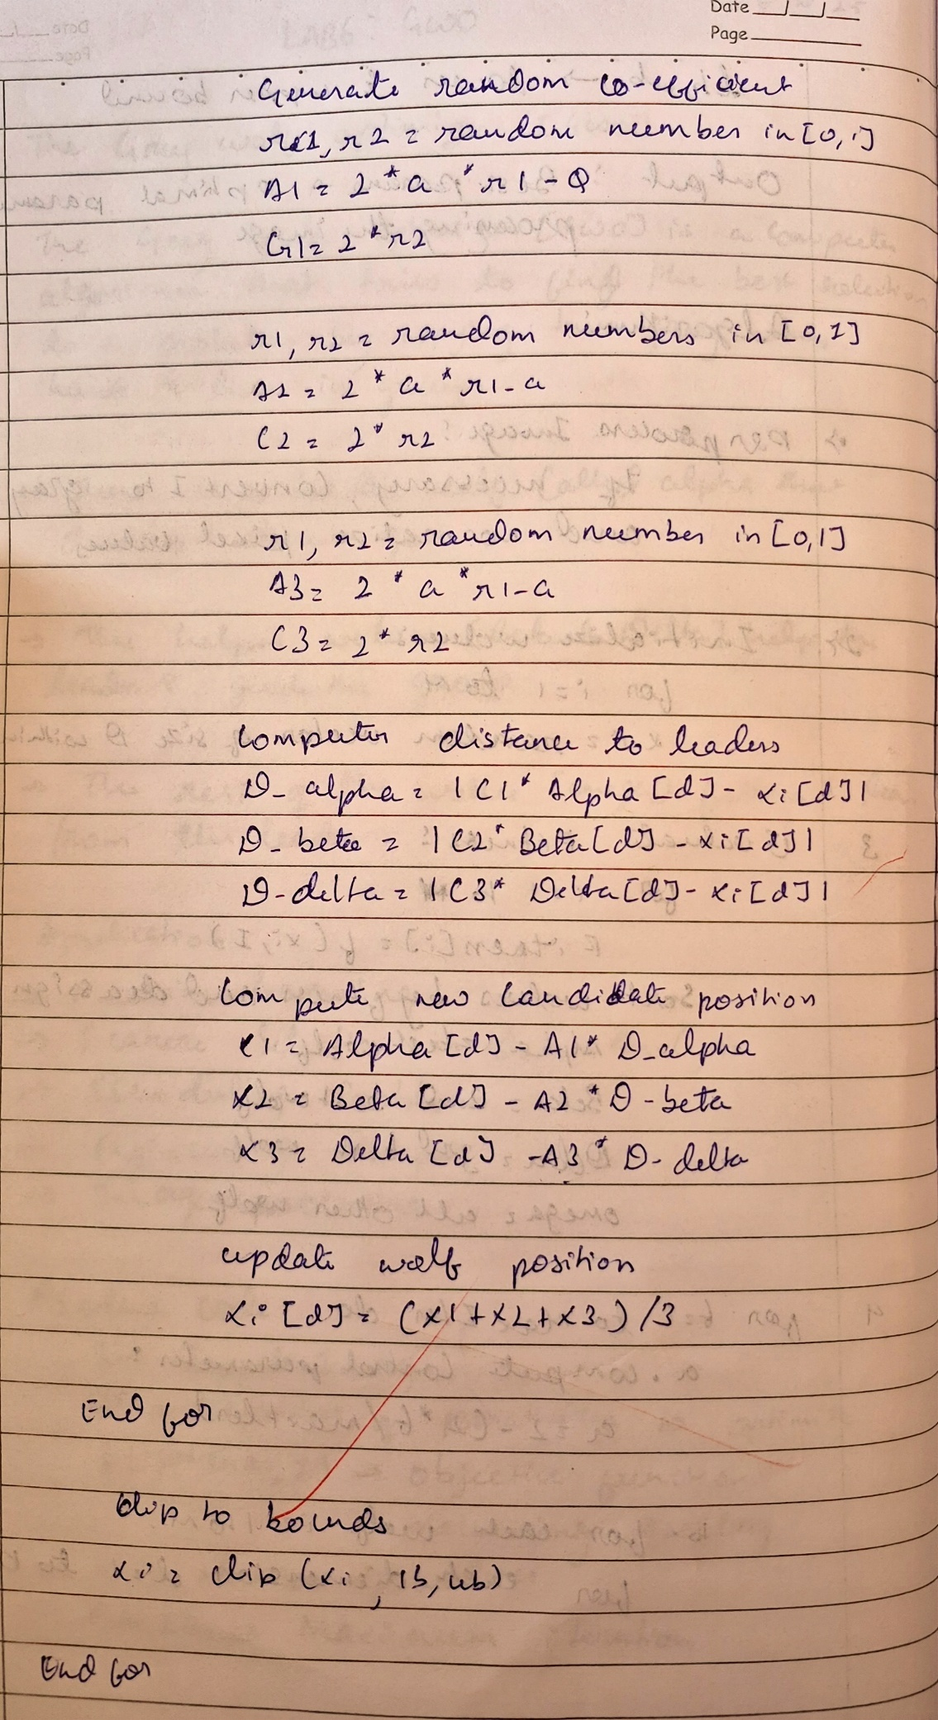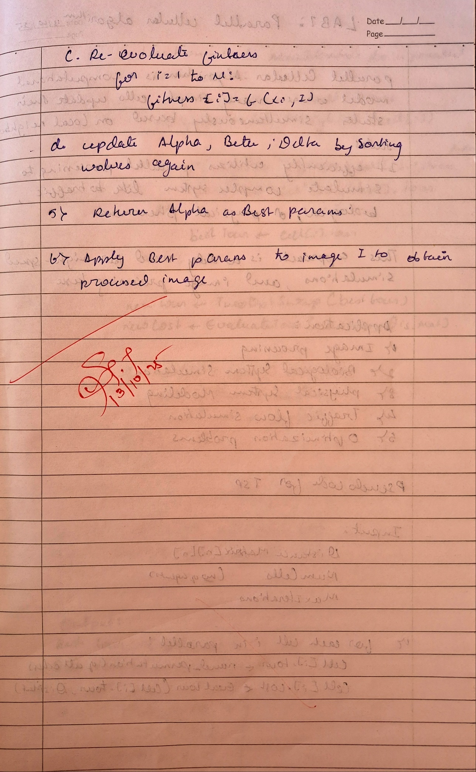

**Code:**

import random

import math

# -------------------------------

# Objective Function: Kapur's Entropy

# -------------------------------

def kapur_entropy(thresholds, image):

thresholds = sorted([int(round(t)) for t in thresholds])

thresholds = [0] + thresholds + [256]

# compute histogram

hist = [0]*256

total_pixels = 0

for row in image:

for pixel in row:

hist[pixel] += 1

total_pixels += 1

# normalize histogram

prob = [h/total_pixels for h in hist]

total_entropy = 0

for i in range(len(thresholds)-1):

start = thresholds[i]

end = thresholds[i+1]

P = [p for p in prob[start:end] if p>0]

total_entropy += -sum([p*math.log(p) for p in P])

return -total_entropy # negative because GWO minimizes

# -------------------------------

# Grey Wolf Optimizer

# -------------------------------

def GWO_image(image, D, N=10, MaxIter=50, lb=0, ub=255):

# Initialize wolves

wolves = [[random.uniform(lb, ub) for _ in range(D)] for _ in range(N)]

alpha_pos = [0]*D

beta_pos = [0]*D

delta_pos = [0]*D

alpha_score = float("inf")

beta_score = float("inf")

delta_score = float("inf")

for t in range(MaxIter):

a = 2 - 2*t/MaxIter

for i in range(N):

fitness = kapur_entropy(wolves[i], image)

if fitness < alpha_score:

delta_score, delta_pos = beta_score, beta_pos[:]

beta_score, beta_pos = alpha_score, alpha_pos[:]

alpha_score, alpha_pos = fitness, wolves[i][:]

elif fitness < beta_score:

delta_score, delta_pos = beta_score, beta_pos[:]

beta_score, beta_pos = fitness, wolves[i][:]

elif fitness < delta_score:

delta_score, delta_pos = fitness, wolves[i][:]

# Update positions

for i in range(N):

for d in range(D):

r1, r2 = random.random(), random.random()

A1 = 2*a*r1 - a; C1 = 2*r2

r1, r2 = random.random(), random.random()

A2 = 2*a*r1 - a; C2 = 2*r2

r1, r2 = random.random(), random.random()

A3 = 2*a*r1 - a; C3 = 2*r2

D_alpha = abs(C1*alpha_pos[d] - wolves[i][d])

D_beta = abs(C2*beta_pos[d] - wolves[i][d])

D_delta = abs(C3*delta_pos[d] - wolves[i][d])

X1 = alpha_pos[d] - A1*D_alpha

X2 = beta_pos[d] - A2*D_beta

X3 = delta_pos[d] - A3*D_delta

wolves[i][d] = (X1 + X2 + X3)/3

# Clip to bounds

if wolves[i][d] < lb: wolves[i][d] = lb

if wolves[i][d] > ub: wolves[i][d] = ub

return [int(round(x)) for x in alpha_pos]

# -------------------------------

# User Interaction

# -------------------------------

def main():

# Load image as 2D list

filename = input("Enter PGM image filename (grayscale): ")

image = []

with open(filename, 'r') as f:

lines = f.readlines()

lines = [l for l in lines if not l.startswith('#')]

if lines[0].strip() != 'P2':

print("Only ASCII PGM (P2) supported.")

return

idx = 2

while len(image) < int(lines[1].split()[1]):

row = list(map(int, lines[idx].split()))

image.append(row)

idx += 1

D = int(input("Enter number of thresholds: "))

N = int(input("Enter number of wolves: "))

MaxIter = int(input("Enter maximum iterations: "))

best_thresholds = GWO_image(image, D, N, MaxIter)

print("Best thresholds found:", best_thresholds)

# Segment image

thresholds = sorted(best_thresholds)

thresholds = [0] + thresholds + [256]

segmented = [[0 for _ in row] for row in image]

for i in range(len(thresholds)-1):

for r in range(len(image)):

for c in range(len(image[0])):

if thresholds[i] <= image[r][c] < thresholds[i+1]:

segmented[r][c] = int((i+1)*(255/(len(thresholds)-1)))

# Save segmented image

out_file = "segmented.pgm"

with open(out_file, 'w') as f:

f.write("P2\n")

f.write(f"{len(segmented[0])} {len(segmented)}\n")

f.write("255\n")

for row in segmented:

f.write(' '.join(map(str,row)) + '\n')

print(f"Segmented image saved as {out_file}")

if __name__ == "__main__":

main()

**Program 6:** Parallel Cellular Algorithms and Programs

Solve a complex optimization problem by dividing the population into semi-independent subpopulations arranged on a grid, enabling parallel evolution and local interaction.

Algorithm:

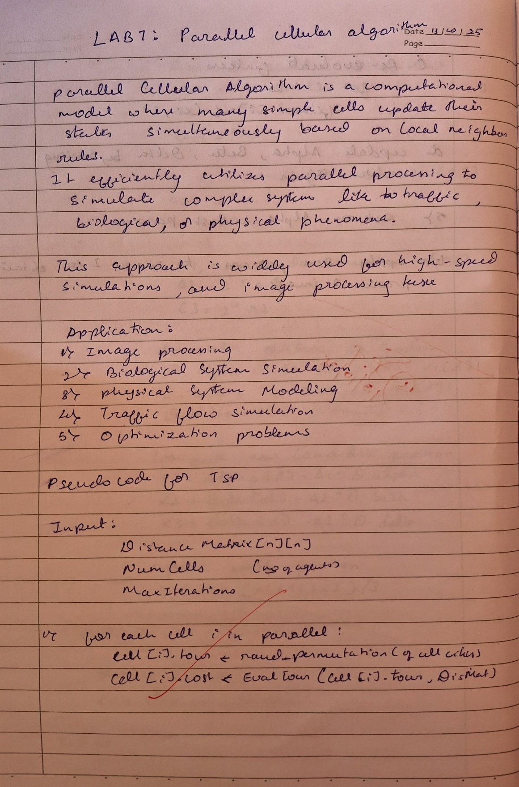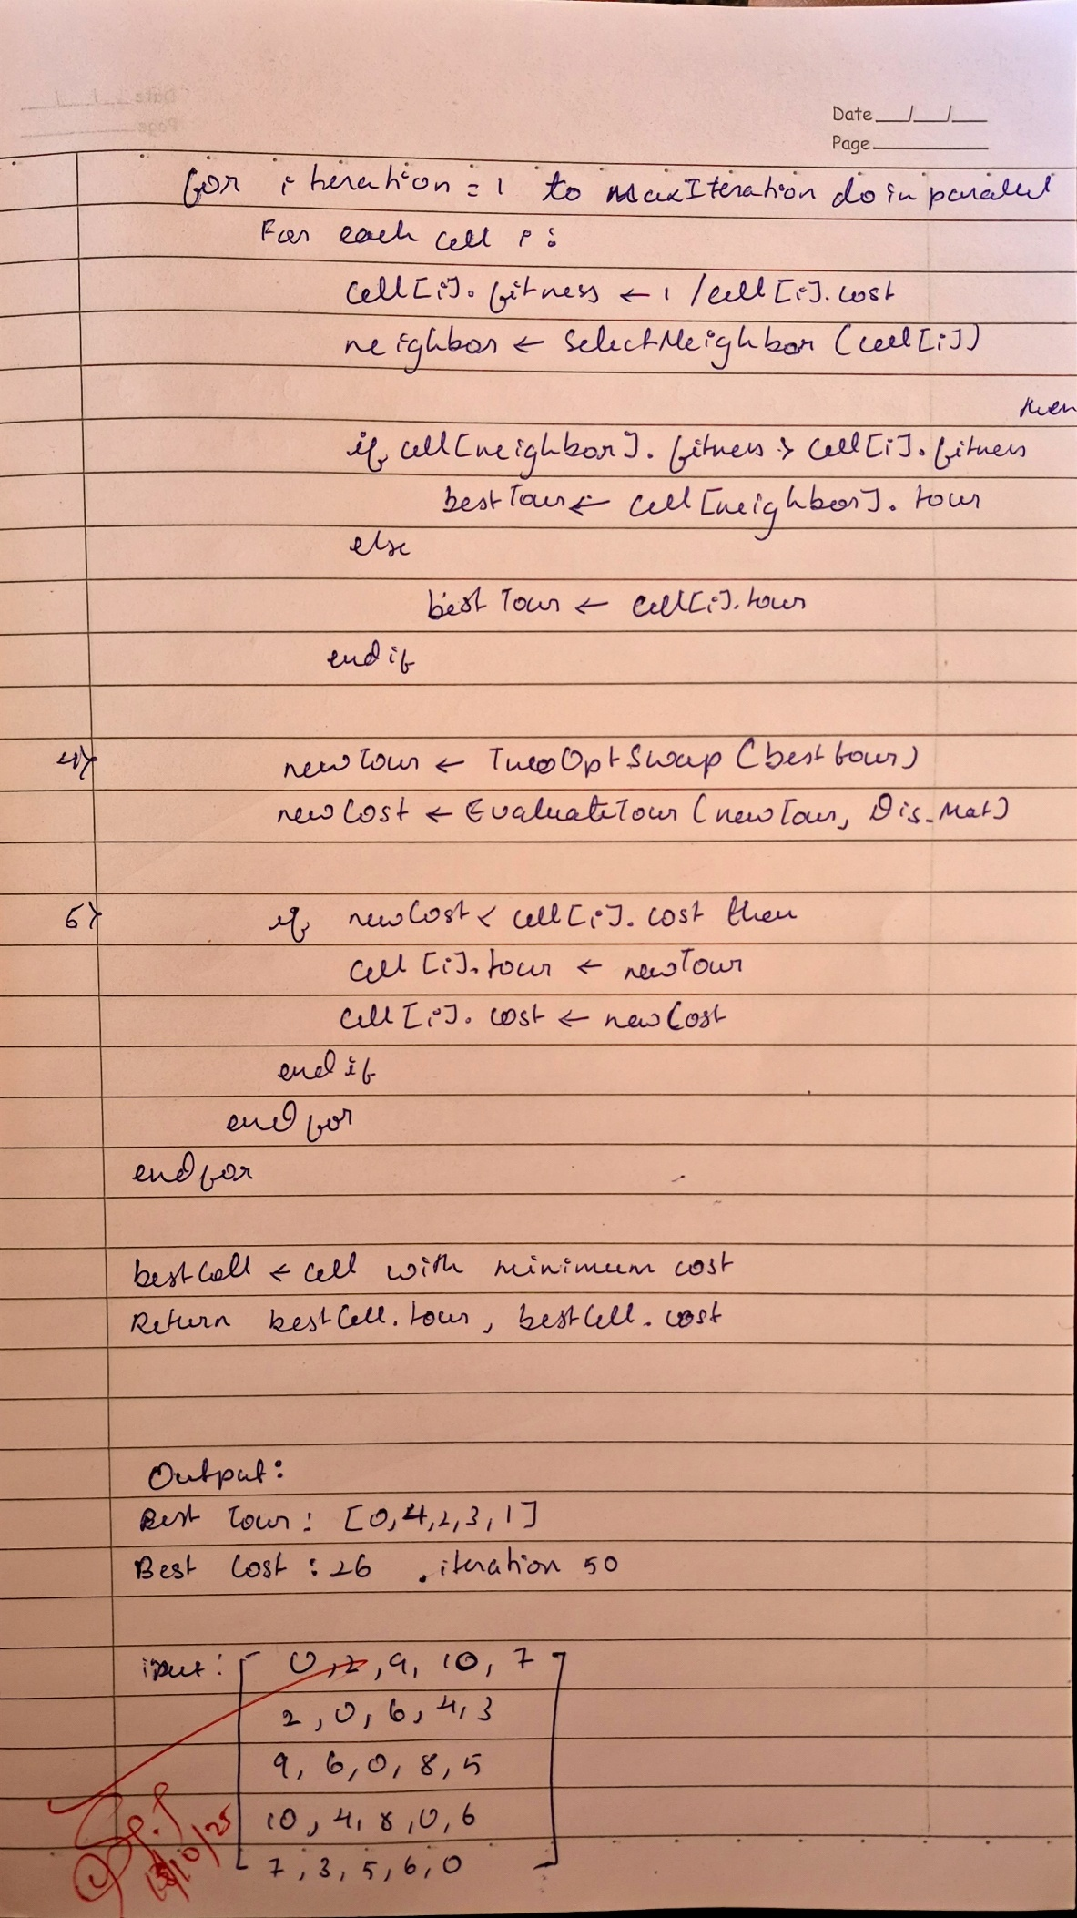

**Code:**

import random

import math

import copy

# ---------- Helper Functions ----------

def tour_cost(tour, dist_matrix):

cost = 0

for i in range(len(tour)):

cost += dist_matrix[tour[i]][tour[(i + 1) % len(tour)]]

return cost

def two_opt_swap(tour):

a, b = sorted(random.sample(range(len(tour)), 2))

tour[a:b] = reversed(tour[a:b])

return tour

def random_tour(n):

tour = list(range(n))

random.shuffle(tour)

return tour

# ---------- PCA for TSP ----------

def pca_tsp(dist_matrix, num_cells=10, iterations=100):

n = len(dist_matrix)

cells = [{'tour': random_tour(n)} for _ in range(num_cells)]

for cell in cells:

cell['cost'] = tour_cost(cell['tour'], dist_matrix)

for _ in range(iterations):

new_cells = []

for i in range(num_cells):

neighbor = cells[(i + random.choice([-1, 1])) % num_cells]

best_tour = neighbor['tour'] if neighbor['cost'] < cells[i]['cost'] else cells[i]['tour']

new_tour = two_opt_swap(copy.deepcopy(best_tour))

new_cost = tour_cost(new_tour, dist_matrix)

if new_cost < cells[i]['cost']:

new_cells.append({'tour': new_tour, 'cost': new_cost})

else:

new_cells.append(cells[i])

cells = new_cells

best = min(cells, key=lambda c: c['cost'])

return best['tour'], best['cost']

# ---------- Example ----------

if __name__ == "__main__":

# Example distance matrix (5 cities)

dist_matrix = [

[0, 2, 9, 10, 7],

[2, 0, 6, 4, 3],

[9, 6, 0, 8, 5],

[10, 4, 8, 0, 6],

[7, 3, 5, 6, 0]

]

best_tour, best_cost = pca_tsp(dist_matrix, num_cells=10, iterations=200)

print("Best Tour:", best_tour)

print("Best Cost:", best_cost)

**Program** **7:** Optimization via Gene Expression Algorithms

Optimize a target function by evolving computer-interpretable expressions or models through gene-regulation-inspired genetic operations.

**Algorithm:**

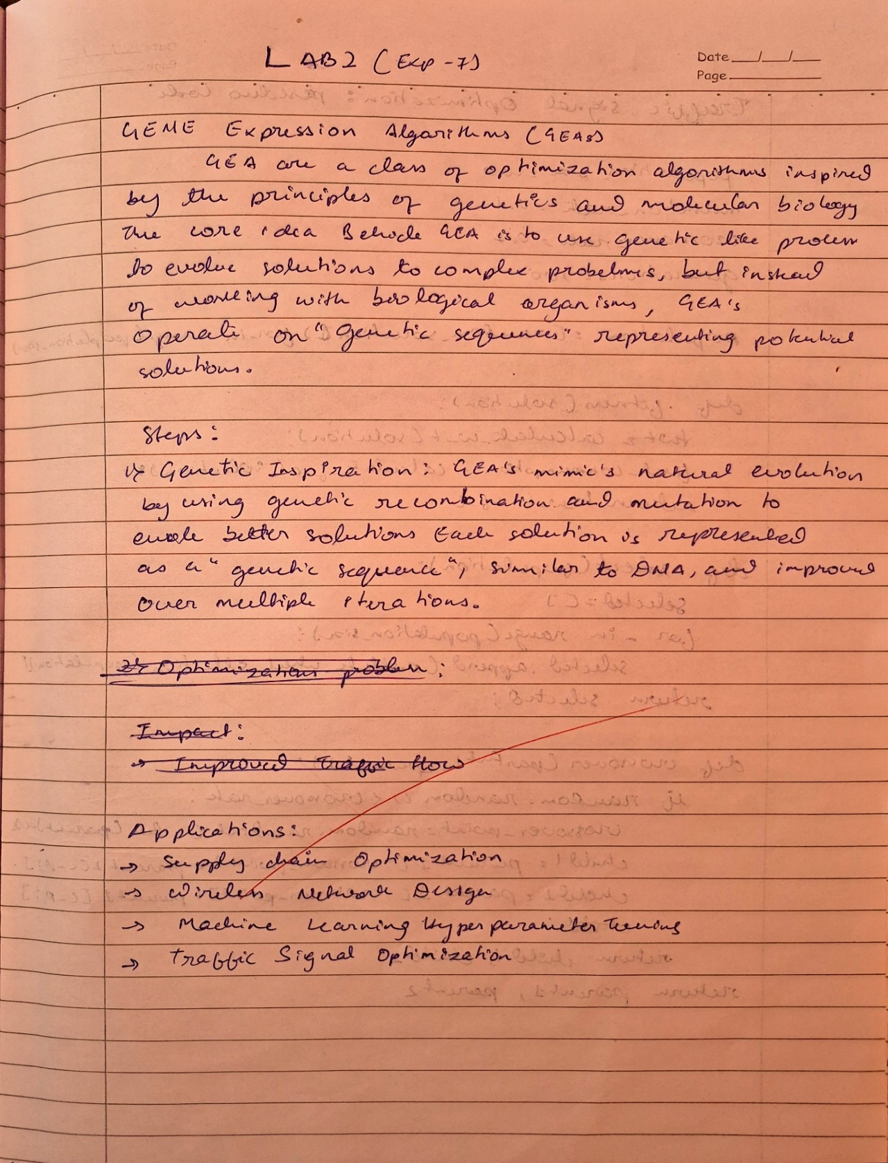

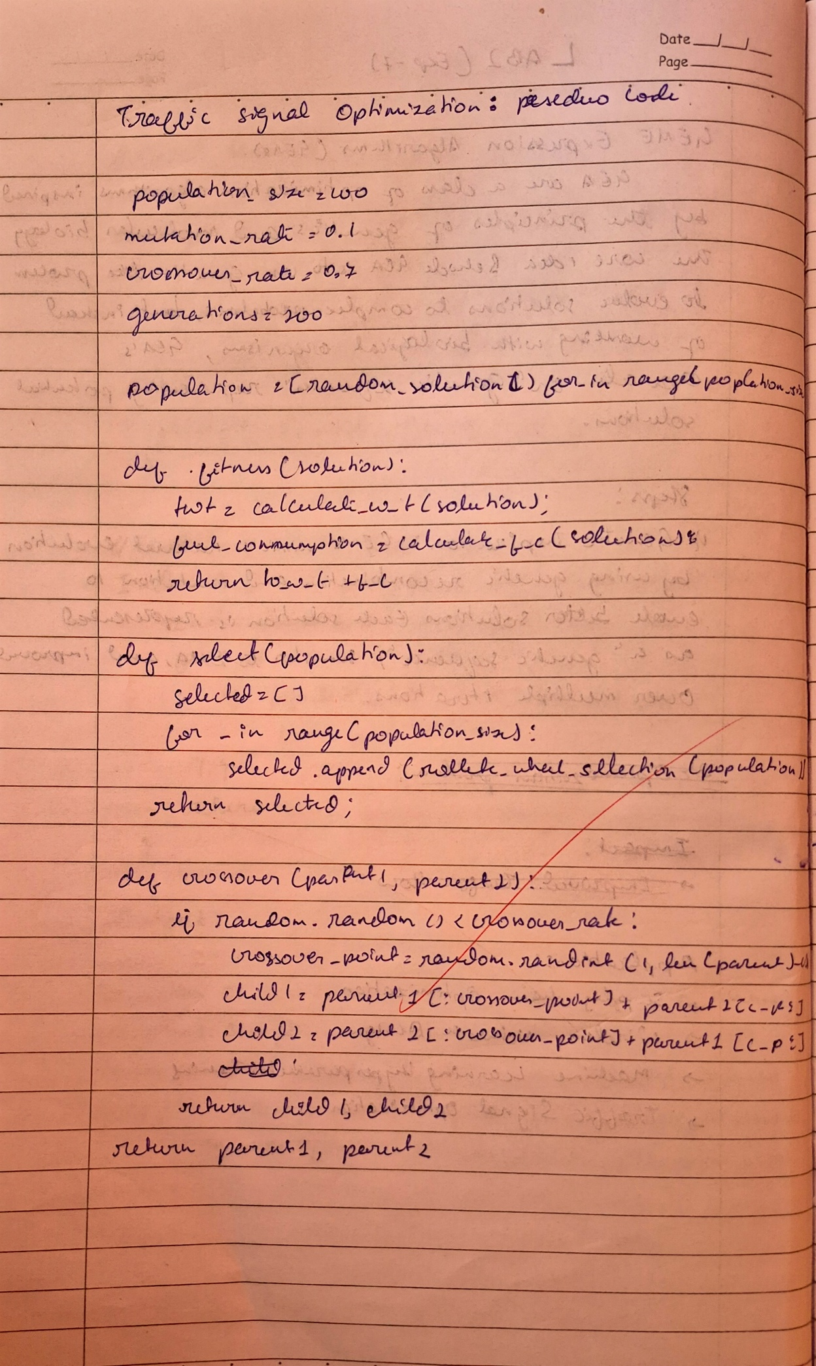

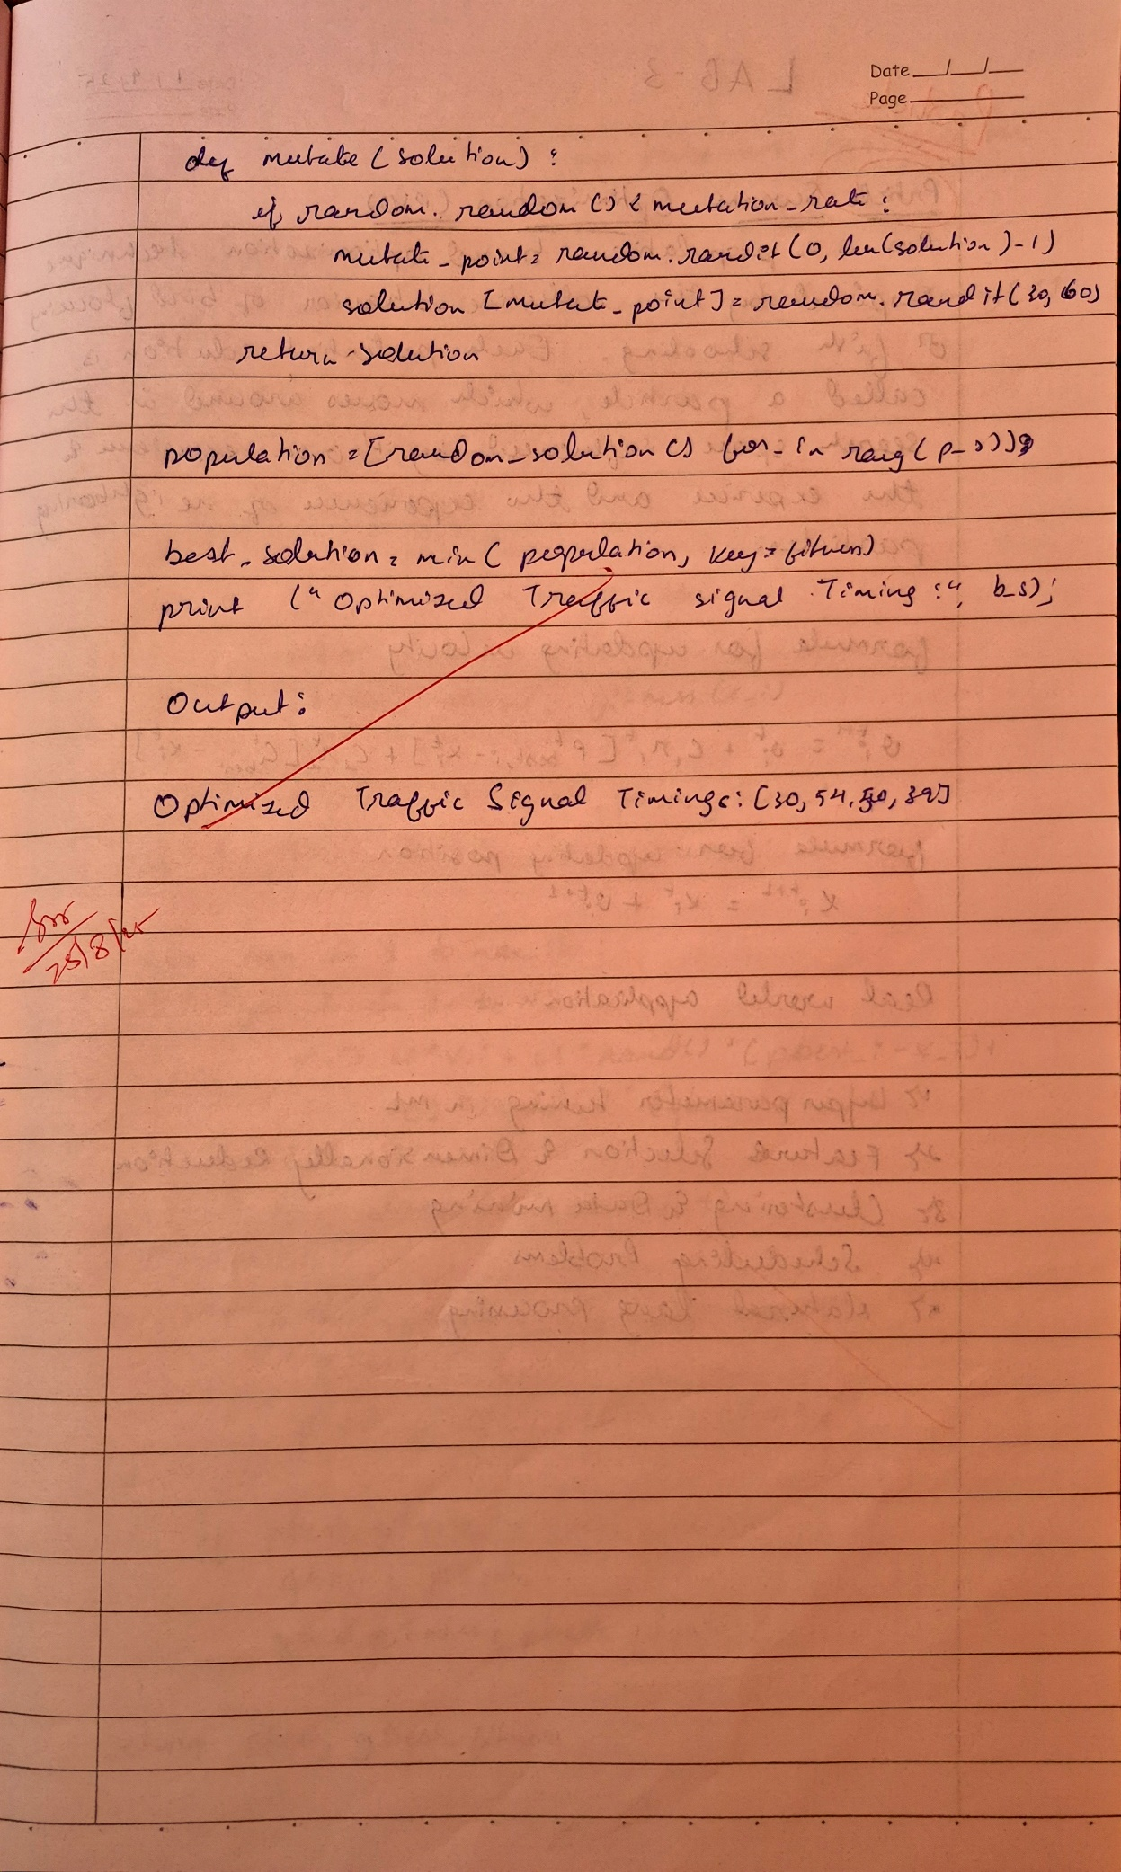

**Code:**

import random

# Parameters

population_size = 100

mutation_rate = 0.1

crossover_rate = 0.7

generations = 200

# Initialize population: Random traffic signal timings (e.g., seconds per intersection)

def random_solution():

return [random.randint(30, 60) for _ in range(4)] # Example: 4 intersections

# Fitness function: Evaluates the solution (total waiting time + fuel consumption)

def fitness(solution):

total_waiting_time = calculate_waiting_time(solution)

fuel_consumption = calculate_fuel_consumption(solution)

return total_waiting_time + fuel_consumption

def calculate_waiting_time(solution):

# Placeholder for actual waiting time calculation based on traffic flow (simplified here)

return sum(solution) # Just sum the signal times as a proxy for waiting time

def calculate_fuel_consumption(solution):

# Placeholder for fuel consumption based on waiting time at red lights

return sum(solution) * 0.05 # Assuming a constant fuel cost per second of waiting

# Roulette Wheel Selection (to select individuals based on fitness)

def roulette_wheel_selection(population, fitness_values):

total_fitness = sum(fitness_values)

pick = random.uniform(0, total_fitness)

current = 0

for i, fitness_value in enumerate(fitness_values):

current += fitness_value

if current > pick:

return population[i]

# Crossover function: Mix two solutions (parents) to produce offspring

def crossover(parent1, parent2):

if random.random() < crossover_rate:

crossover_point = random.randint(1, len(parent1)-1)

child1 = parent1[:crossover_point] + parent2[crossover_point:]

child2 = parent2[:crossover_point] + parent1[crossover_point:]

return child1, child2

return parent1, parent2

# Mutation function: Randomly adjust a solution

def mutate(solution):

if random.random() < mutation_rate:

mutate_point = random.randint(0, len(solution)-1)

solution[mutate_point] = random.randint(30, 60) # Example: Randomize signal times

return solution

# Main GEA loop

population = [random_solution() for _ in range(population_size)]

for generation in range(generations):

# Evaluate fitness for the current population

fitness_values = [fitness(individual) for individual in population]

# Select individuals using Roulette Wheel Selection

selected_population = [roulette_wheel_selection(population, fitness_values) for _ in range(population_size)]

# Create the next generation through crossover and mutation

new_population = []

for i in range(0, population_size, 2):

parent1, parent2 = selected_population[i], selected_population[i+1]

child1, child2 = crossover(parent1, parent2)

new_population.append(mutate(child1))

new_population.append(mutate(child2))

# Replace the old population with the new one

population = new_population

# Output the best solution after all generations

best_solution = min(population, key=fitness)

print("Optimized Traffic Signal Timings:", best_solution)